The Fitch® Fuel Catalyst for oil burner application is designed to:
- Reduce Fuel Consumption
- Reduce Emissions
- Improve Efficiency
- Improve Overall Performance
- Provide a Cleaner Burn

The Fitch Fuel Catalyst is a patented alloy that creates a molecular change in hydrocarbon fuels such as fuel oil and diesel.

This molecular transformation is similar to the refining process. The refinery uses heat and pressure to refine fuel the Fitch Fuel Catalyst reformulates fuel at the time of use.

First, the improved combustion resulting from the catalyst increases the heat output per gallon burned. This enables the burner fuel nozzle size to be reduced. Less fuel is required to obtain the same BTU output.

Second, the improved combustion also means cleaner burning of the fuel. The heating appliance will stay cleaner for a longer time. This means the heating system will maintain a higher degree of operating efficiency over a longer time period and require less maintenance.

The Fitch® Fuel Catalyst is installed in the fuel delivery line. It is a maintenance-free device.
SAVE ENERGY
&
POLLUTE LESS

Installation of the Fitch® Fuel Catalyst must be performed by a qualified technician. The special instruments and equipment used by the technician are required to ensure the proper installation and operation of the unit. The technician will assure that the proper nozzle size has been selected for the burner and that inlet air, stack temperatures, and soot levels are measured and adjusted correctly.

New York City Housing Authority

Boiler: Johnson PFTX-350-31LG15S
Burner: Johnson FD69CA400LM

Results: 5% - 9% Reduction in Fuel Consumption
Reduction in Emissions – CO 98%, NOx 15%
NYCHA Install

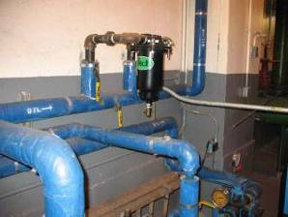

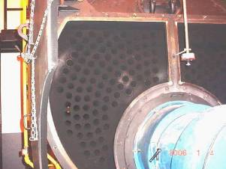

Before Fitch Installation

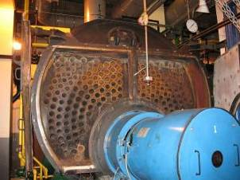

After Fitch Installation

Virginia Beach, VA: Colombian furnace with AFG Beckett Burner with 0.85 gph* nozzle. After Fitch installation stack temps increased 45 degrees indicating over fueling. The nozzle was then reduced to a 0.75 gph saving 12% in fuel

Camden, ME: Peerless JOTTW275 BOILER with Beckett burner rated at 2.75 gph, equipped with a 2.25 nozzle, after installing a Fitch Fuel Catalyst, we were able to reduce nozzle size.

The Fitch® Fuel Catalyst is available for all
commercial and residential oil burners. Guaranteed for 5 years.

Savings will depend on the size and maintenance condition of the oil burner, the heating requirements of the building and, of course, weather conditions. The percent of actual savings may vary but payback is typically within the first year of installation.

$2.50 per gallon – 20000 gallons per year

10% savings first year = $5,000.00
10% savings 5 yr = $25,000.00

15% savings first year = $7,500.00
15% savings 5 yr = $37,500.00

20% savings first year = $10,000.00
20% savings 5 yr = $50,000.00

25% savings first year = $12,500.00
25% savings 5 yr = $62,500.00

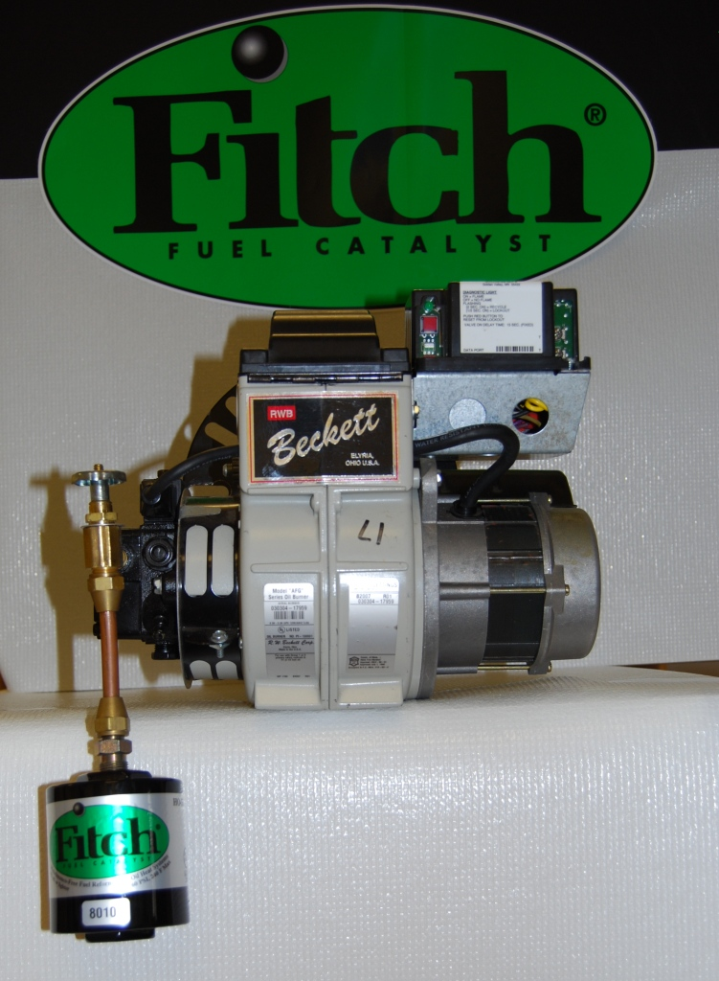

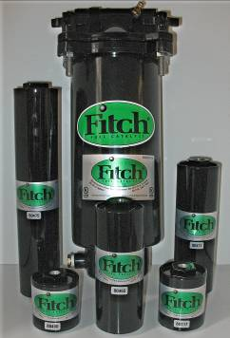

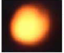
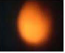
Without Fitch With Fitch installed

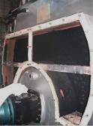
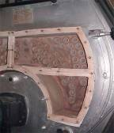
Without Fitch With Fitch installed

Fitch produces a more efficient combustion process resulting in visible brightness in flame and reduction in soot build up.

www.gofitch.com
Ralph Armstrong
1-866-463-4824
email: fitch@av.eastlink.ca
Made in the USA


